

**JIELIMISHE LIBRARY MANAGEMENT INFORMATION SYSTEM**

**1. 0 BACKGROUND STUDY**

Jielimishe library in and initiative of a Non- Governmental Organization established in the year 2007 based on kibera and mathare to help communities in slum areas to access basic knowledge by providing books (both study and reference), audio visual materials (CDs and DVDs) newspapers and magazines and other research materials. Jielimishe also provides children’s section where they can study and even relax and do their story telling film show while they are on their holidays.

**1. 1 PROBLEM DEFINITION**

Access to education and research materials is a menace in slum areas and according to constitution it is a right entitled to everyone. This has led to available books and research materials taken/stolen and end up leading to more loss to the organization therefore makes need to develop more sophisticated system the will help curb this issue.

**1.2 OVERVIEW OF EXISTING SYSTEM**

Jielimishe library does not have automated system and all process are done manually. Once an individual want to borrow any book he/she needs to be a member of jielimishe library, in order to be a member one needs to provide the following information:

* National identity card
* Pay a total of ksh.100 monthly fee and ksh.100 yearly subscription
* He/she is a resident of specific slum all be known by referred friend.
* School identity card for pupils/students
* Individual functional number/parent/guardian number.

Once an individual has provided the above information, it takes a week for librarian to process membership card for the individual and he/she is allowed to borrow a maximum of 2 books and return the within a span of 4 days for study books and 8 days for research and novels. Incase he/she does not return the book within the given period the individual incurs a penalty of ksh.20 a day and once settle the penalty he/she will be blacklisted for a period of 1 month and will be allowed to borrow the again.

In case the individual does not provide all information required for registration, the registration is suspended until he/she provides full information and they are just allowed to study within the library.

**DISADVANTAGES**

* It is slow-This is due to use of manual system
* It is not accurate-The system used may give wrong outputs to the users
* The system is not secure – as the paper based filing system can be easily altered and damaged.
* Consume a lot of money-a lot of money is used to purchase materials used to record transactions.
* A lot of time is consumed during record searching.

**1.3 OVERVIEW OF THE PROPOSED SYSTEM**

The proposed system uses modern technology of computer system. The system is used to key in personal details on registration, capture the total number of books taken/borrowed and check on on return date.in case someone fail to return the books it while capture the extra dates and the penalty. The system uses database based on MsSql server which is able to generate reports and queries while using visual basic.Net platform language which generates user interface. The system enable users to computerize input data, data updates and generate reports by using modules such as add, delete, update on the screen user interface which are three consisting of driver details, vehicle details and route details.

**1.4 BENEFITS OF THE PROPOSED SYSTEM**

* The proposed system is able to tell total registered members and produces reports
* The proposed system is able to utilize the large storage devices to save and retrieve documents.
* The proposed system is able to produce neat work to the end user.
* The proposed system is able to provide security thus preventing loss of data and use password preventing authorized people to access the data.
* The proposed system is able to update the files and generate daily reports.
* Proposed system reduces expenses which were entailed in maintaining the paper based filing system.

**1.5 AIM OF THE STUDY**

The general aim of the project is to develop a system which is able Capture personal details on registration, issue membership number, have a database of all borrowed books and produces weekly and monthly reports, and finally calculate the fines incase someone overstay with the book,

**1.6 GENERAL OBJECTIVES**

* To carry out feasibility study
* To carry out system analysis within Library
* To design the system of the library
* Coding of library system
* To implement the system.

**1.7 THE SPECIFIC OBJECTIVES**

* To develop a system that provides actual number of registered members.
* To develop a system that provides total fine collected.
* To develop a system that provides reports

**1.8 PROJECT SCHEDULE**

|  |  |  |  |  |  |  |  |  |
| --- | --- | --- | --- | --- | --- | --- | --- | --- |
| Activity | JAN | JAN | FEB | FEB | FEB | MARCH | MARCH | MARCH |
| Feasibility study |  |  |  |  |  |  |  |  |
| System analysis |  |  |  |  |  |  |  |  |
| System design |  |  |  |  |  |  |  |  |
| Coding |  |  |  |  |  |  |  |  |
| Documentation |  |  |  |  |  |  |  |  |
| Implementation |  |  |  |  |  |  |  |  |

# CHAPTER TWO

# LITERATURE REVIEW

## 2.1 INTRODUCTION

This chapter describes the definition of literature review, information systems, types of information systems, Operations of the system.

## 2.2 LITERATURE REVIEW

According to Chris (2009) literature review refers to a text written by someone to consider the critical points of current knowledge including substantive findings as well as theoretical and methodological contributions to a particular topic. Literature reviews are secondary sources and as such, do not report any new or original experimental work. Also, a literature review can be interpreted as a review of an abstract accomplishment. Most often associated with academic-oriented literature, such as a thesis or peer-reviewed article, a literature review usually precedes a research proposal and results section. Its main goals are to situate the current study within the body of literature and to provide context for the particular reader. Literature reviews are a staple for research in nearly every academic field

An **information system** is a collection of hardware, software, data, people and procedures that are designed to generate information that supports the day-to-day, short-range, and long-range activities of users in an organization. Information systems generally are classified into five categories: office information systems, transaction processing systems, management information systems, decision support systems, and expert systems. The following sections present each of these information systems.

### 2.2.1 Jielimishe Library Information System

Library Management System is about better access to information and Research materials.

These systems are implemented to:

* To develop a system that provides actual number of registered members.
* To develop a system that provides total fine collected.
* To develop a system that provides reports

## 2.3 OPERATION OF THE SYSTEM

This is the method through which the system will be analyzed and implemented. The method to be used in the system development is the structured analyze and structural design method (SSADM) This method will help us analyses the problems and design /implementation following defined stages and procedures. It is a method where logical and physical models of a system will be constructed using the data flow diagrams for the following steps both in manual and proposed system. Ideal Sacco management information is an automated system that will be used to run the firm.

The system will be used to key in vehicle details, recording the amount paid by the vehicle and daily collection. Although we have different databases like Microsoft access and programming languages like java, Pascal and C++,The system will use database based on Ms Sql server which will be able to query the data while visual basic.net language will be able to create user interface. The proposed system will enable to computerize input data, data updates and generate reports. The interface will have commands that will enable the user to add, edit, delete and update records. It will be able to run on any operating system if installed.

## 2.4 METHODOLOGIES

This is the method through which the system will be analyzed and implemented. The methodology that will be used will be Structured Systems Analysis and Design Methodology (SSADM). SSADM is a waterfall method by which an IS design can be arrived at; SSADM can be thought to represent a pinnacle of the rigorous document-led approach to system design.

# CHAPTER THREE

# SYSTEM ANALYSIS

## 3.0 INTRODUCTION

This chapter covers system analysis, its definition, objectives of system analysis, problem analysis, terms of reference, professional or stakeholders of the system, methodology that will be used in the development of the proposed system, requirements of the proposed system, feasibility study and its report and fact-finding methods and their advantages

## 3.1 Definition of system analysis

(Morse and Kimball (1951). Defines system analysis as a process of collecting factual data, understand the processes involved, identifying problems and recommending feasible suggestions for improving the system functioning. It also involves the evaluation of the current system using gathered information to ascertain whether it meets the requirements of the user both current and the proposed and the subsequent recommendation of what is to be done.

## 3.2 Objectives of system analysis

* To provide an assessment of the existing system
* To understand the nature of the system
* To produce a statement of requirement specification
* To ensure that the new system caters for the process required to generate the required information from a given set of data items (inputs)
* To ensure that the weakness of the current system are identified and removed from the new system framework
* To help evaluate the possible alternative solutions

## 3.3 TERMS OF REFERENCE

### 3.3.1 Title of the project

**JIELIMISHE LIBRARY MANAGEMENT INFORMATION SYSTEM**

### 3.3.2 Aim of the Study

The general aim of the project is to develop a system which is able Capture personal details on registration, issue membership number, have a database of all borrowed books and produces weekly and monthly reports, and finally calculate the fines incase someone overstay with the book,

### 3.3.3 Justification

The current system is ineffective and incapable of managing the sacco Database with increased number of customers and a higher number expected in the near future. The proposed system tends to solve these problems for the sacco easing all the activities of both revenue collection and managing the sacco. Manager is able to easily generate and submit revenue reports of the daily collection.

### 3.3.4 Advantages for proposed system

* The proposed system is able to tell total registered members and produces reports
* The proposed system is able to utilize the large storage devices to save and retrieve documents.
* The proposed system is able to produce neat work to the end user.
* The proposed system is able to provide security thus preventing loss of data and use password preventing authorized people to access the data.
* The proposed system is able to update the files and generate daily reports.
* Proposed system reduces expenses which were entailed in maintaining the paper based filing system.

### 3.3.5 Scope

The proposed system will be used by the individuals:

* Members
* staff

### 3.3.7 Professionals and stakeholders

**System Users**

The system users are the people who use the system on a regular basis to support the operation and management of the library.

**System Analysts**

Systems analysts are people who determine the requirements that must be met by the jielimishe library management system to meet the needs of the customers, management and other users.

**Systems Designers**

Systems designers are technical specialists who select appropriate technologies and make the essential requirements into practical requirements of the proposed system

**System Builders**

Systems builders are technical specialists who build, test, and deliver the system

**The Managers**

The manager establishes, analyze, appraise, and interpret performance. They communicate the meaning of the measurement and their findings to the library users. They also select people for the jobs to be done to achieve the objectives of the library system.

## 3.4 METHODOLOGIES.

This is the method through which the system was analyzed and implemented. The methodology that was used was Structured Systems Analysis and Design Methodology (SSADM). SSADM is a waterfall method by which an IS design can be arrived at; SSADM can be thought to represent a pinnacle of the rigorous document-led approach to system design.

**Reasons for using SSADM**

* It is easy to use i.e. high-quality system is delivered at the end of the project
* Use of easily understood non-technical diagrammatic techniques
* It’s easier to plan manage and control project
* Special emphasis is put on the analysis of user needs
* It gives a possibility to tailor the planning of the project to the actual equipment’s of the business
* It reduces the error rate of information system by defining a certain quality level in the beginning and constantly checking the system
* It separates the logical and physical system design so the system does not have to be implemented again with new hard or software.

**Tools used in SSADM**

The tools in structured system analysis and design methodology (SSADM) that the analyst will use are:

Data flow diagrams (DFD’S) that shows the flow of data through the system and the procedures that take place in it

Flow charts, which are diagrammatic representations of steps necessary to solve a problem and are easy to understand and the representation of logic are a guide of identification and also tools for documentations.

Data dictionary

Entity life history and diagrams

**Steps used in SSADM**

SSADM is a waterfall view approach whereby there are sequences of events that run in series and each step leads on from the last. There are five steps in total, and each step can be broken down further.

1. **Feasibility study** – To determine whether it is cost effective to go ahead with the system and whether it is actually possible.

2. **Requirements Analysis** – Identifying of the requirements and needs of the system and modeling these needs in terms of the processes carried out.

3. **Requirements Specification** – The functional and non-functional requirements are identified in detail.

4. **Logical System Specification** – Technical systems options are created and the logical design of the system created. This includes the design of update and enquiry processing.

5. **Physical Design** – The logical system specification and technical system specification is used to design a physical database and set of program specifications

**SSADM Structure**

Project Identification

Feasibility Study

Project Definition

Analyze system operation and current problem

Specification Requirement

**SSADM**

Physical design

System Analysis

System Design

Data Design

Process Design

## 3.5 REQUIREMENTS FOR PROPOSED SYSTEM

**Hardware requirements**

|  |  |  |
| --- | --- | --- |
| **Activities** | **Data** | **Documents** |
| Input requirement | Data sources include customer details, services offered by the farm, the staff who attend to customers. | Use of keyboard to key in the details, mouse for navigation and cameras for taking pictures |
| Output requirement | Document generated include: receipts, invoices, paying vouchers | Printer for printouts like receipts, Compaq 17’’ TFT monitor for display |
| Storage requirement | Files to be stored include: customer registration, farm services, staff details and sales details. | Flash disk, hard disk compact disk |

**Software requirements**

Windows 2010 home edition for an operating software

Microsoft office 2007

Word for documenting

Access for database

Visual basic.net

## 3.6 FEASIBILITY STUDY

Is the preliminary study of current system and proposed system to find out the possibility and visibility of developing a new system. It is supposed to allow the management to decode whether or not to commit resources to the development or modification of the new system.

### 3.6.1 Technical feasibility

This determines the availability of technical skills, sustainability of the project and maintainability. It helps to determine whether the proposed system can be developed and implemented using existing technology which includes hardware and software.

### 3.6.2 Schedule feasibility

It analyses the time given for completing the system development and the actual completion time. The system will take six months to be completed.

### 3.6.3 Schedule Feasibility

|  |  |
| --- | --- |
| January | Problem definition, Data collection |
| February | System analysis, System design and construction |
| March | System testing and debugging |

### 3.6.4 Economical feasibility

Determined if the benefits to be delivered from the system recommendations are worth the time, money and the required resource, from the study the costs incurred by the existing system are high in terms of labor, cost of stationary and storage methods. The costs were tabulated in the table below.

**Existing system**

|  |  |
| --- | --- |
| **Existing system** | **Proposed system** |
| **Particulars** | **Amount(ksh)** | **Amount(ksh)** |
| Labor cost | 100000 | 10000 |
| Stationary | 40000 | 120000 |
| Storage/manual | 60000 | 8000 |
| **Total** | **200,000** | **138,000** |

### 3.6.5 Operational Feasibility

The proposed system will require high cost because of the machinery involved, but soon after the machinery is bought the cost will reduce drastically.

## 3.7 FEASIBILITY REPORT

This is an investigation that determines whether the proposed project is viable or not. Feasibility study report is that which is agreed upon by the organization and is implemented to the benefit of the organization. It is a measure and study of how beneficial the development of the project will be beneficial to the organization.

### 3.7.1 Introduction

The feasibility report was given to the organization management in order to access the findings of the developer.

### 3.3.2 Cost benefits analysis

This refers to comparing the cost of the current system and the benefits of the proposed system.

**Economic Feasibility Report**

**Current system costing**

|  |  |
| --- | --- |
| **Product/item** | **Amount(Ksh)** |
| **Labor** | **150,000** |
| **Files** | **20,000** |
| **Stationary** | **20,000** |
| **Miscellaneous** | **10,000** |
| **Total** | **200,000** |

**Proposed system benefits and savings**

|  |  |  |
| --- | --- | --- |
| **Product/item** | | **Amount(Ksh)** |
| **Labor** | | **40,000** |
| **Computers** | | **80,000** |
| **Printers** | | **7,000** |
| **Storage media** | | **4,000** |
| **Maintenance** | | **3,000** |
| **Training** | **4,000** | |
| **Total** | **138,000** | |

## 3.9 DATA FLOW DIAGRAM

This is diagram that gives an overall view of data processing and procedure in the system. It shows logical flows of data and processing steps involved. It uses symbols that are industry conventions standardized by the ISO.

|  |  |  |
| --- | --- | --- |
| **Symbol Name** | **Symbol** | **Description** |
| Data Flow |  | It shows the movement of data within the system and is used to connect components of the diagram |
| External entity/ Terminator |  | It represents anything that interacts with the system but not part of the system. it can be a user or the management of the organization |
| Data store |  | It holds data processed by the system i.e. stores data in the system. Represents data in files either manual or automated. |
| Process |  | It is an activity within a system that transforms the input data into output data. Process ID is a unique number that identifies the process which is obtained by following the levelling rules. Locality is where the process is taking a place e.g a department |

***Activity Diagram***

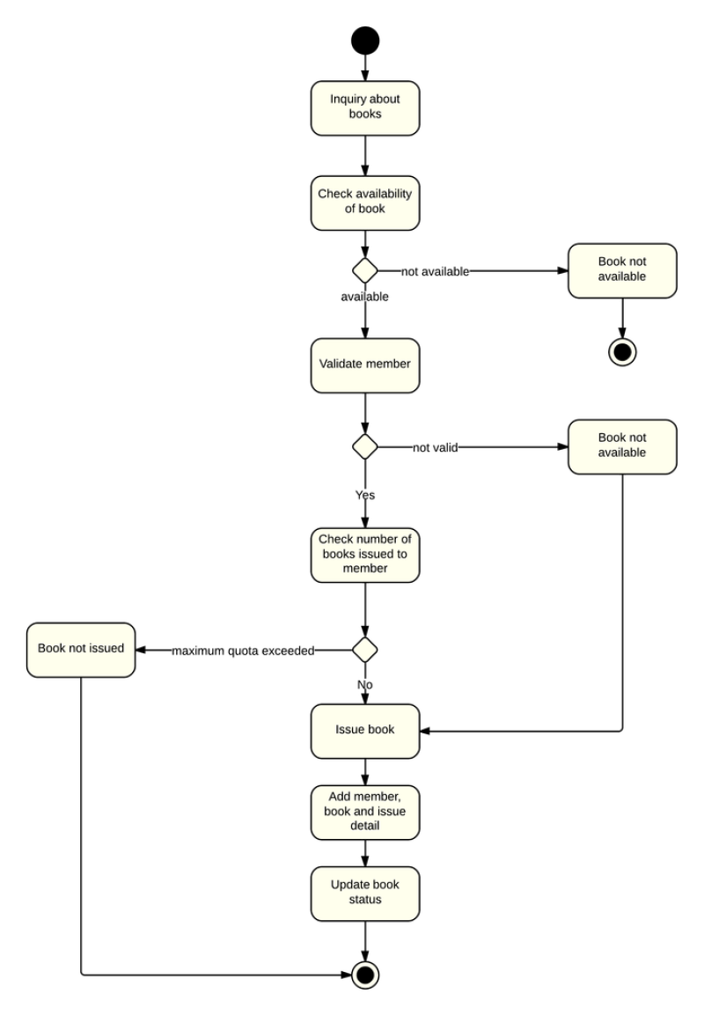

**Activity Diagram**

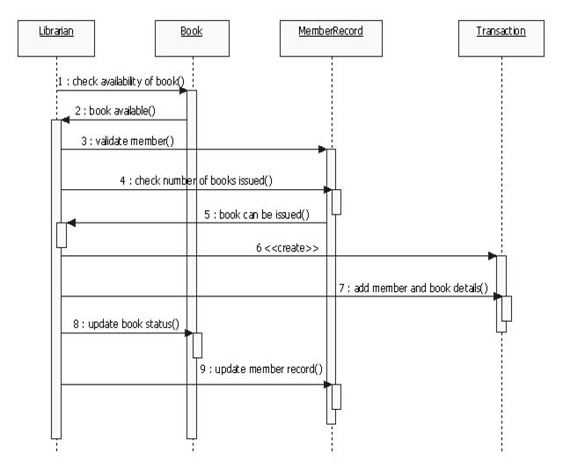

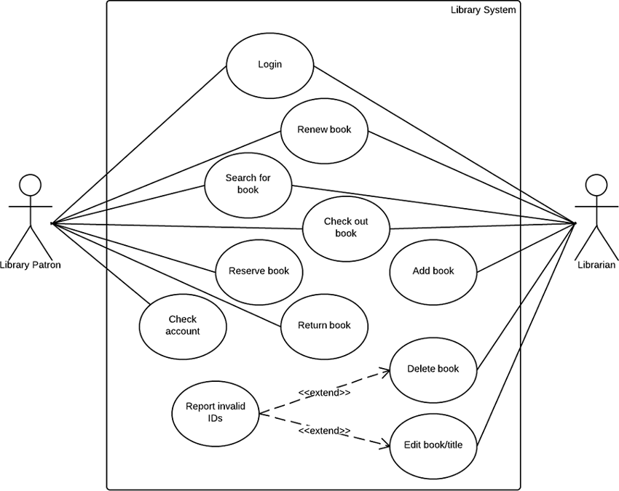**use case digram**

**SWIMLANE DIAGRAM**

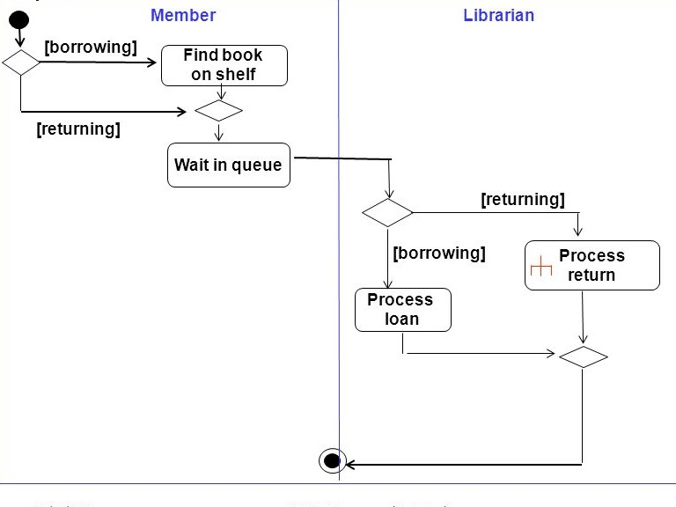

# SYSTEM SCREENSHOTS

